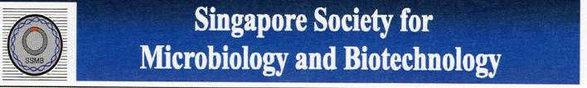

Food Pathogen Appreication Workshop
Registration Form
Name : _______________________________
Designation: _______________________________
Company: _______________________________
Address: _______________________________
_______________________________
Contact: _______________________________
Email: _______________________________

Are you a current SSMB member : Yes / No
Registration Fee : Non-member $50.00, Member $25.00
(Only fully paid-up membership qualifies for the above Member registration fee. Please send your registration form together with cheque payment, crossed and made payable to Singapore Society for Microbiology and Biotechnology to reach SSMB by Friday, 1st November 2013. Kindly attention to Ms. Leong May Ling, c/o Department of Microbiology, YLLSoM, No. 5 Science Drive 2, Singapore 117597.)

